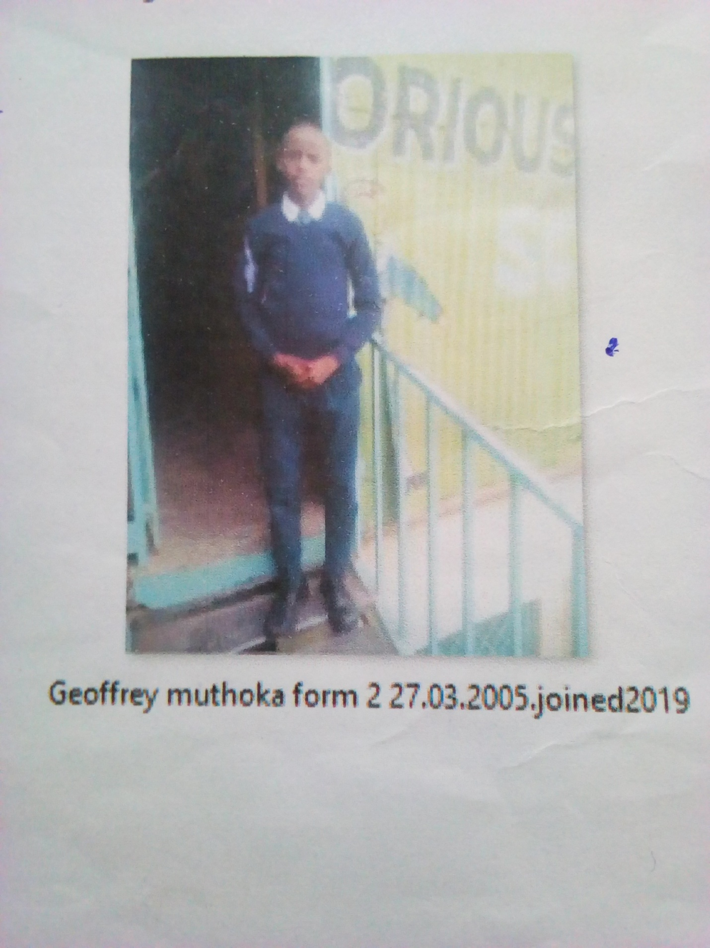
GEOFFREY MUTHOKA FORM 2 BORN 2005 JOINED 2019
Geoffrey 16 years was enrolled in our school when he was 14 years old. Geoffrey is an orphan boy, his parents died of blood pressure. Being very energetic young and vibrant he became a victim domestic violence from his relatives. He sought help in school and he became accepted in school after the Director was contacted.
Thanks to the Director Mr. Boniface Mangeti who allowed Geoffrey in school. I am now learning in glorious at least I have a place I call home praying that one day God will help our school have good classes, toilets and enough study materials. Thank you Michell and Brad for your support have really helped many in Mukuru

